**DGT 212: Digital Humanities**

**Group -14**

**Aayushi Shah - AU2140159**

**Aditya Dave - AU2140100**

**Dev Bhalodia - AU2140208**

**Shrimad Patel - AU2200008**

**Soham Pathak - AU2110237**

**Vedant Patel - AU2140178**

# Data Essay:

## **Introduction to Mythology and Folklore:**

The study of folklore and mythology, though ancient in origin, became a formal academic discipline in the 19th century, particularly in Europe, notably Germany. This systematic approach to folklore stemmed from various social, political, and historical contexts, leading to a diversity of motivations for its exploration. Initially, ambiguity surrounded the term "folklore" itself, which was used interchangeably to denote both the subject of study and its materials. Across different regions, folklore encompassed various cultural expressions, from unsophisticated peasant customs to relics of the past, reflecting differing societal perceptions. Despite originating from diverse disciplinary backgrounds such as literary studies, anthropology, and psychology, folklore studies gradually evolved into an independent academic discipline in the 20th century, enriched by interdisciplinary contributions. Ultimately, folklore and mythology provide invaluable insights into the collective consciousness of societies, shaping cultural identities and offering guidelines for understanding the human experience.

[youtube.com/watch?v=vxea5EU6Si4&ab_channel=MythologyStoryteller](http://youtube.com/watch?v=vxea5EU6Si4&ab_channel=MythologyStoryteller)

### **Methodology:**

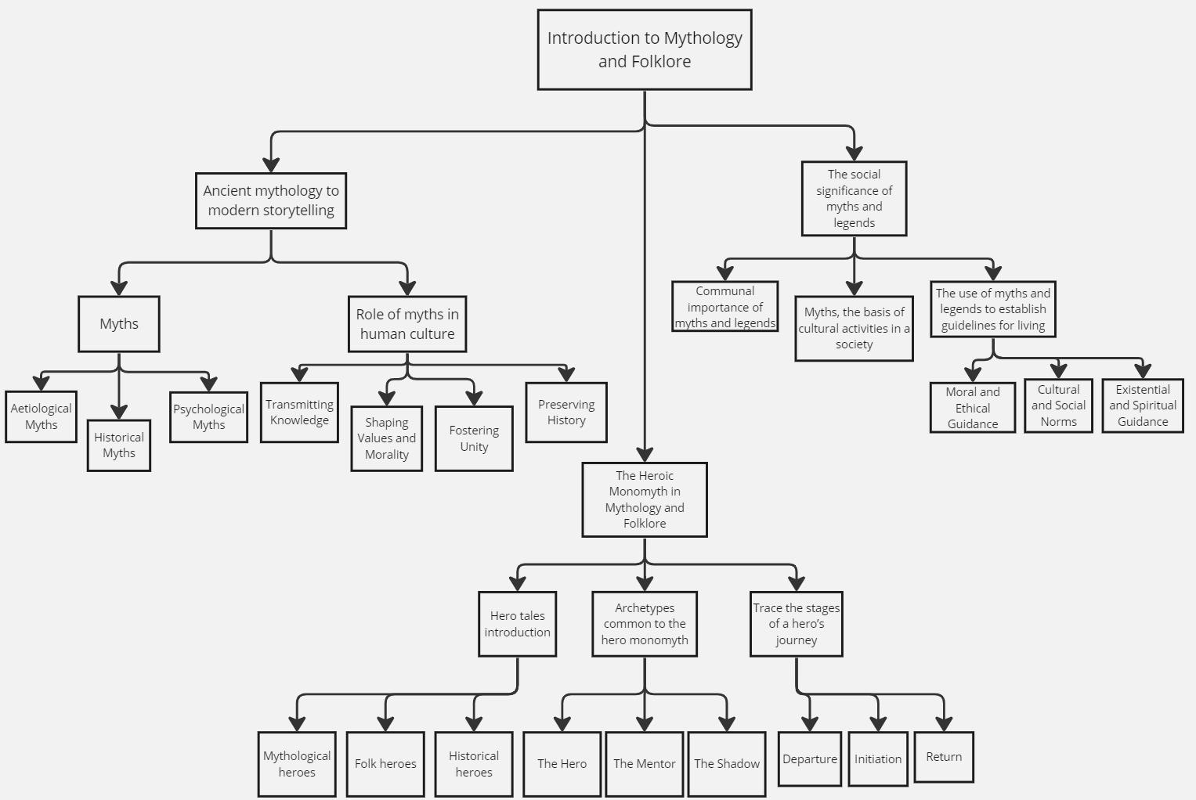

### **Ancient mythology to modern storytelling:**

### Ancient mythology serves as the timeless foundation upon which modern storytelling builds its towering structures of imagination. As civilizations evolve, so too do the narratives that shape our understanding of the world. The transition from ancient mythology to modern storytelling reflects a continuum of human expression, where age-old themes of love, betrayal, heroism, and redemption find new resonance in contemporary contexts. While ancient myths were once whispered around campfires and etched onto temple walls, today, they find life in novels, films, video games, and digital media, evolving with the times yet retaining their fundamental essence. This transition is not merely a shift in medium but a testament to the enduring power of storytelling to capture the human experience across generations and cultures, bridging the gap between the ancient and the modern with threads of universal truth and imagination.

#### Myths:

* A myth is a story that may or may not be true. The definition of the word Myth is still subject to debate. Myths may be very old or new, such as urban myths.
* Myth expresses the total vision of the human situation, destiny, inspiration, and apprehensions.
* It is a tradition that we inherit from our forefathers.
* Myth considers both the meaning bad and good at a time.

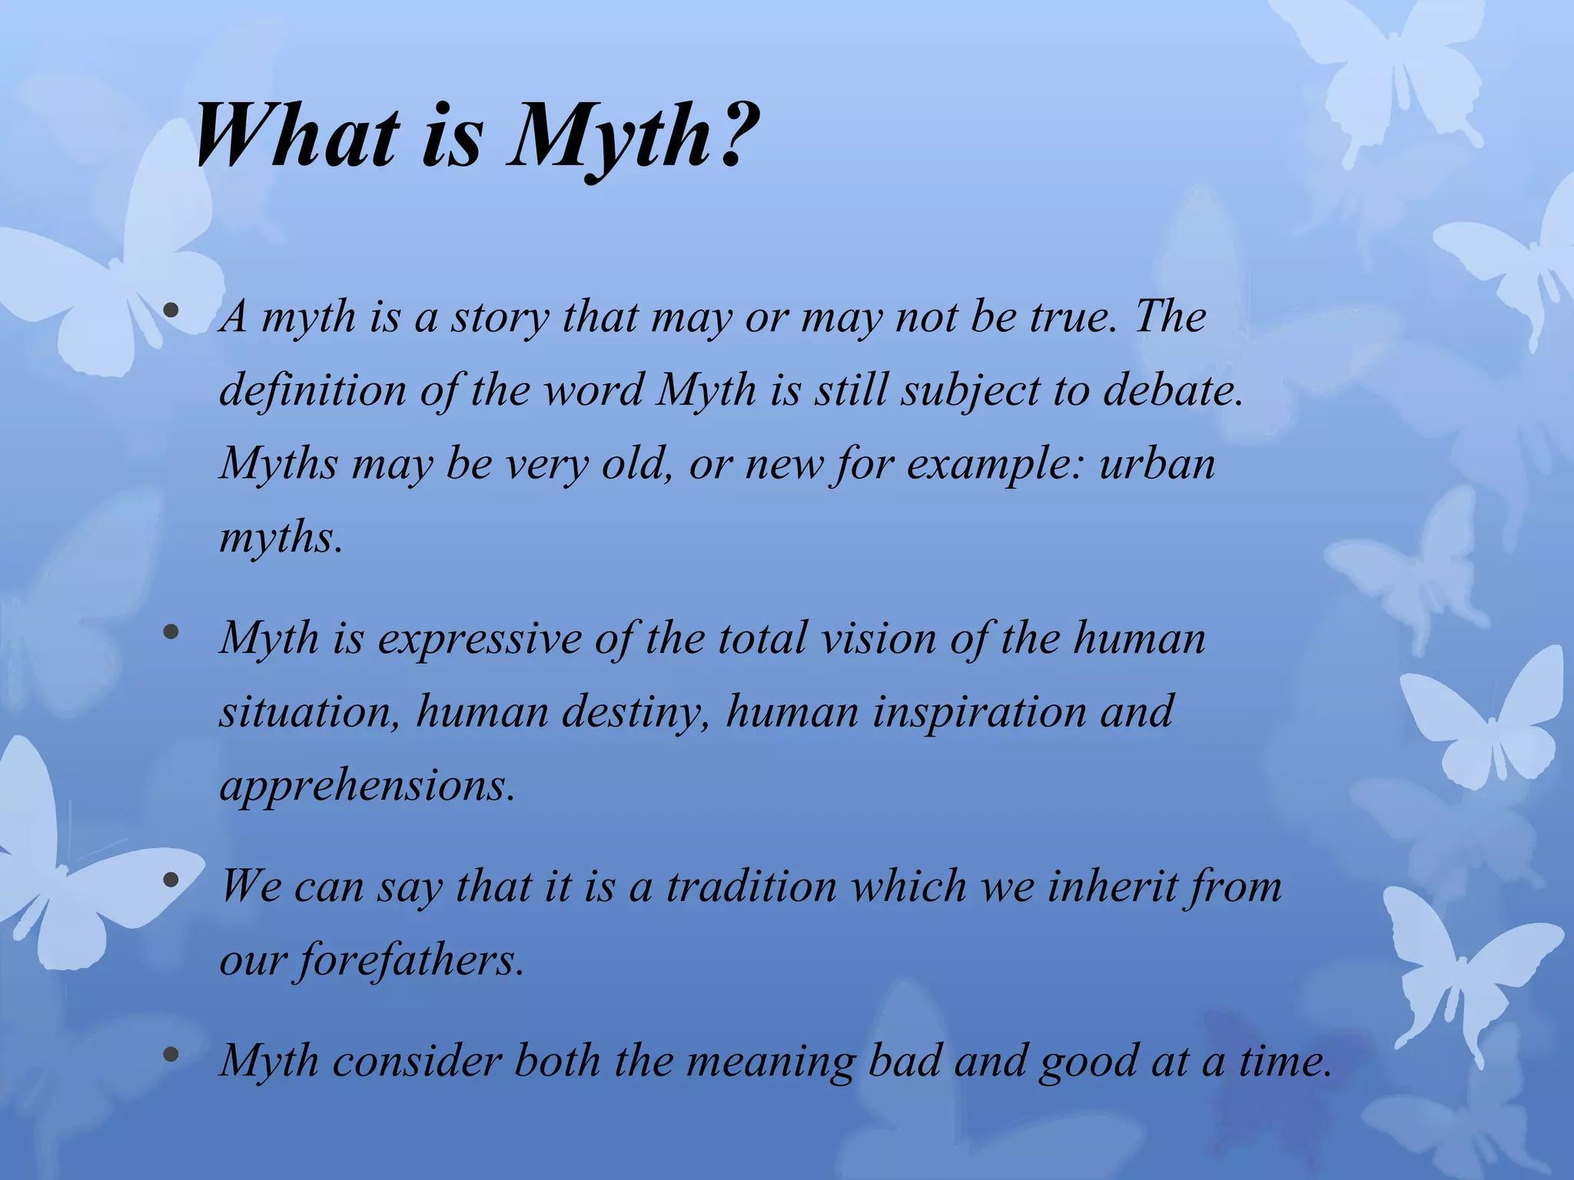

[youtube.com/watch?v=xlAdS7uWhLA&ab_channel=TheLearningDepot](http://youtube.com/watch?v=xlAdS7uWhLA&ab_channel=TheLearningDepot)

Reference: <https://www.slideshare.net/Devikaba/what-is-myth>

Let's discuss some of the popular myths.

1. Myth of Orpheus and Eurydice: The myth of Orpheus and Eurydice is a poignant tale of love, loss, and the power of music. Orpheus, a gifted musician, descends to the realm of the dead to rescue his beloved Eurydice, who died from a snake bite. With his enchanting melodies, Orpheus persuades Hades to release Eurydice under one condition: he must not look back until they both reach the surface. Tragically, Orpheus succumbs to doubt and looks back, losing Eurydice forever. This myth explores the fragility of human resolve and the eternal quest for love beyond the boundaries of life and death.

2. Myth of Cupid and Psyche: The myth of Cupid and Psyche is a tale of divine love and mortal trials. Psyche, a mortal princess of extraordinary beauty, incurs the jealousy of Venus, the goddess of love. As punishment, Psyche is sent on a series of impossible tasks by Venus, guided by Cupid, the god of love, who falls deeply in love with her. Despite the challenges and misunderstandings, their love ultimately triumphs, demonstrating the enduring power of the soul's connection to love, even across the realms of the mortal and the divine. This myth delves into themes of trust, perseverance, and the transformative nature of love's trials.

3. Myth of Oisín and the land of eternal youth: The myth of Oisín and the Land of Eternal Youth recounts the captivating journey of Oisín, a legendary Irish hero. Drawn by tales of eternal youth and beauty, Oisín embarks on a perilous quest to Tír na nÓg, the mystical land beyond the sea. There, he falls deeply in love with Niamh, a fairy princess, and lives in bliss for what seems like mere moments. However, upon returning to the mortal world, centuries have passed, and Oisín finds himself a stranger in a changed land. This myth explores the allure of eternal youth, the passage of time, and the bittersweet consequences of pursuing an unattainable dream.

4. Myth of "The Egyptian Book of the dead": The Egyptian Book of the Dead, known as the "Book of Coming Forth by Day," is a profound ancient text guiding souls through the afterlife journey. Comprised of spells, prayers, and rituals, it serves as a guidebook for navigating the challenges of the underworld and achieving eternal life. The book emphasizes the importance of morality, judgment, and the preservation of the soul in the journey to the realm of Osiris, the god of the afterlife. Through its elaborate instructions and vivid imagery, the Book of the Dead provides insight into ancient Egyptian beliefs about death, rebirth, and the cosmic order of existence.

5. Myth of Chinese zodiacs: In the Chinese zodiac, your shuxiang, or animal sign, is determined by the year of your birth rather than the month. The origin of these animal signs is rooted in the myth of The Great Race, a timeless tale that explains their arrangement. According to the myth, the Jade Emperor invited animals to participate in a race to determine their order in the zodiac. Each animal's characteristics and attributes were tested during the race, resulting in the twelve animals of the Chinese zodiac, each symbolizing different personality traits and fortunes for those born under their sign. Megan Campisi and Pen-Pen Chen retell this enduring myth, which continues to shape Chinese culture and astrology today.

6. Myth of Indian Lord Rama: The myth of Lord Rama, an embodiment of virtue and righteousness in Hindu mythology, narrates the epic journey of the prince of Ayodhya. Rama's life is depicted in the ancient Indian epic, the Ramayana, which recounts his exile, the abduction of his wife Sita by the demon king Ravana, and his quest to rescue her with the help of his loyal companion Hanuman. Throughout his trials and tribulations, Rama upholds dharma (righteousness) and serves as a paragon of honor, compassion, and duty. His tale continues to inspire devotion and moral guidance across generations, symbolizing the triumph of good over evil and the enduring power of faith and righteousness.

##### Aetiological Myths:

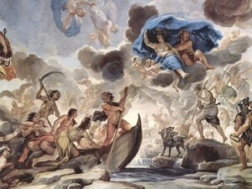

Aetiological (sometimes spelled etiological) myths explain the reason why something is the way it is today. The word aetiological is from the Greek word aetion (αἴτιον), meaning “reason” or “explanation”. Please note that the reasons given in an aetiological myth are NOT the real (or scientific) reasons. They are explanations that have meaning for us as human beings. There are three subtypes of aetiological myths: natural, etymological, and religious.

A natural aetiological myth explains an aspect of nature. For example, you could explain lightning and thunder by saying that Zeus is angry.

An etymological aetiological myth explains the origin of a word. (Etymology is the study of word origins.) For example, you could explain the name of the goddess Aphrodite by saying that she was born in sea foam, since aphros is the Greek word for sea foam.

A religious aetiological myth explains the origin of a religious ritual. For example, you could explain the Greek religious ritual of the Eleusinian Mysteries by saying that they originated when the Greek goddess Demeter came down to the city of Eleusis and taught the people how to worship her.

<https://www.youtube.com/watch?v=JbCFI2fX48A&ab_channel=KellyStryker>

##### Historical Myths:

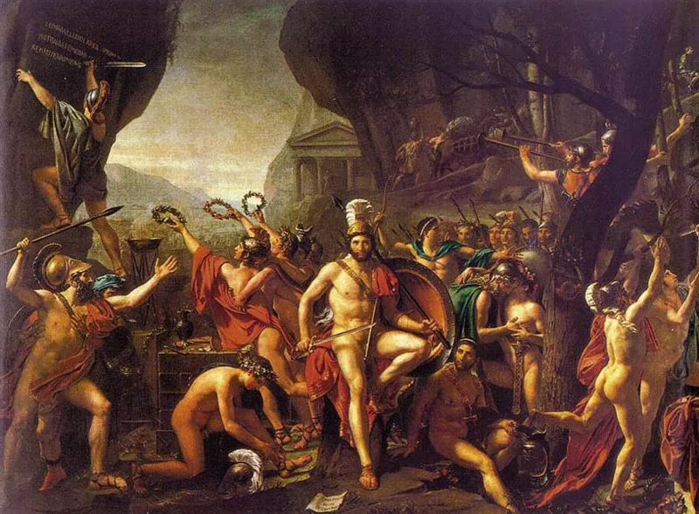

Historical myths are told about a historical event, and they help keep the memory of that event alive. Ironically, in historical myths, the accuracy is lost but meaning is gained. The myths about the Trojan War, including the Iliad and the Odyssey, could be classified as historical myths. The Trojan War did occur, but the famous characters that we know from the Iliad and the Odyssey (Agamemnon, Achilles, Hector, etc.) probably did not exist.

<https://www.youtube.com/watch?v=_mgDW_U1prQ>

Reference: <https://www.thoughtco.com/top-historical-myths-debunked-1221615>

##### Psychological Myths:

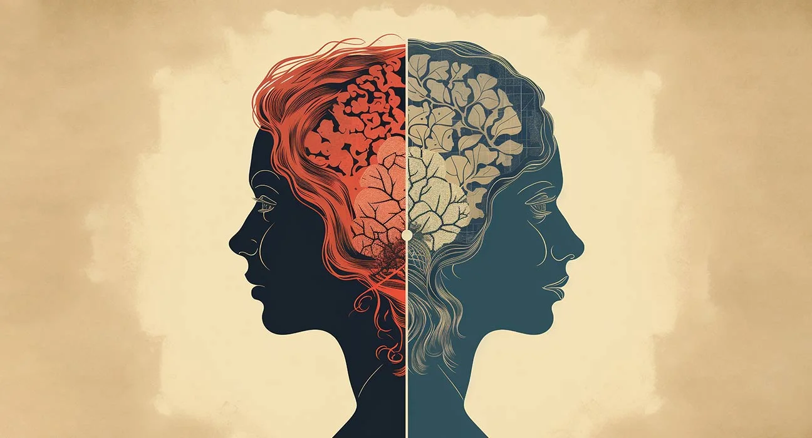

Psychological myths try to explain why we feel and act the way we do. A psychological myth is different from an aetiological myth because a psychological myth does not try to explain one thing by way of something else (like explaining lightning and thunder with Zeus’ anger does). In a psychological myth, the emotion itself is seen as a divine force, coming from the outside, that can directly influence a person’s emotions. For example, the goddess Aphrodite is sometimes seen as the power of erotic love. When someone said or did something that they did not want to do, the ancient Greeks might have said that Aphrodite “made them” do it.

<https://www.youtube.com/watch?v=vHhn7z6BA0w&ab_channel=TEDxTalks>

Reference: <https://uen.pressbooks.pub/mythologyunbound/chapter/three-types-of-myth/#:~:text=Psychological%20myths%20try%20to%20explain,with%20Zeus'%20anger%20does>).

Word Clouds:

**1. The Creation of the World in Hawaiian Mythology:** In Hawaiian mythology, the world is born from the divine union of Papa, the Earth Mother, and Wākea, the Sky Father. Their love gives rise to the islands of Hawai'i, shaped and adorned by the creative forces of gods like Kāne. The resulting world is a lush paradise teeming with life, where every aspect of nature reflects divine benevolence and interconnectedness. The Hawaiian creation myth serves as a psychological narrative by instilling a sense of interconnectedness, beauty, and harmony, fostering a positive worldview and promoting emotional well-being.

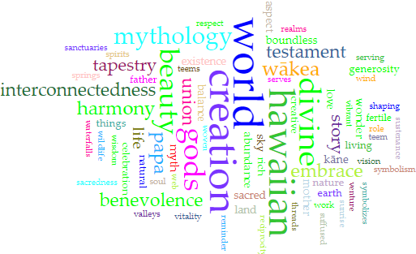

**The Creation of the World in Hawaiian Mythology**

A word cloud generated from this text showcases prominent terms such as "Hawaiian", "mythology", "creation", "divine," "World", "Sky", "beauty," "harmony", and "interconnectedness.",

**2. Ragnarök, Norse Mythological story:** In Norse mythology, Ragnarök symbolizes a cataclysmic event heralding the end of the world. The term itself, translating to "Doom of the Gods" or "Dusk of the Gods" in Old Norse, foreshadows a grim fate. Ragnarök unfolds as a series of calamities, signifying the annihilation of the cosmos, yet from this devastation arises the possibility of renewal, albeit tinged with bleakness.

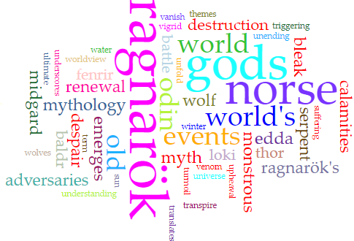

**Ragnarok, Norse mythology**

A word cloud generated from this text highlight terms such as "Norse", "mythology", "Ragnarök", "destruction", "battle","vanish", "bleak", and "unending" illustrating the thematic essence of the mythological narrative.

Sentiment Analysis:

<https://colab.research.google.com/drive/15LdBT6SNXbjMJposAiAEQ3pdkgXMBJQj?usp=sharing>

#### 

#### Role of Myths in Human Culture:



Mythology plays a fundamental role in human culture by serving as a repository of collective wisdom, values, and beliefs passed down through generations. It provides a framework for understanding the world and our place within it, offering explanations for natural phenomena, human behavior, and the mysteries of existence. Mythology also fosters cultural identity and solidarity, uniting communities through shared narratives, rituals, and symbols. Moreover, myths inspire creativity, serving as a source of inspiration for literature, art, religion, and philosophy, while offering timeless insights into the human condition. In essence, mythology enriches human culture by providing a tapestry of stories and archetypes that illuminate the complexities of life and ignite the imagination.

##### Transmitting knowledge:

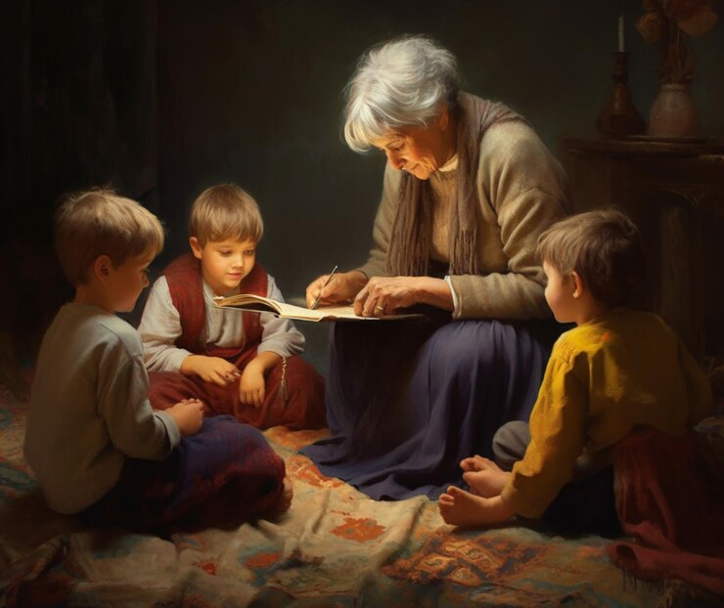

When considering the transmission of knowledge through mythological stories and folklore, it's crucial to recognize their role as vessels of wisdom and understanding passed down through generations.

Preservation of Cultural Wisdom:

Mythological stories and folklore encapsulate the accumulated wisdom of cultures and societies, preserving their knowledge, beliefs, and values across time. For example, the Navajo creation myth, which recounts the emergence of the Navajo people and their relationship with the land, serves as a repository of traditional ecological knowledge, teaching principles of sustainability and reverence for nature.

Teaching Moral and Ethical Lessons:

These narratives often convey moral and ethical lessons through allegorical tales of heroes, gods, and mythical creatures. For instance, Aesop's fables, such as "The Tortoise and the Hare" and "The Ant and the Grasshopper," impart timeless truths about diligence, patience, and the consequences of one's actions, offering practical guidance for navigating life's challenges.

Inspiring Curiosity and Inquiry:

Mythological narratives spark curiosity and inspire further inquiry into the mysteries of the world, encouraging individuals to explore their cultural heritage and seek deeper understanding. The Norse myth of Yggdrasil, the world tree, for example, prompts reflection on the interconnectedness of life, death, and the cosmos, inviting contemplation and philosophical inquiry.

In essence, mythological stories and folklore serve as conduits for transmitting knowledge, encompassing cultural wisdom, moral teachings, explanations of natural phenomena, and insights into the human experience. By imparting this knowledge to successive generations, these narratives play a vital role in preserving heritage, fostering learning, and shaping collective consciousness.

##### 

##### Shaping values and morality

Myths play a pivotal role in shaping values and morality by conveying cultural norms, ethical principles, and societal ideals through storytelling. These narratives serve as moral compasses, guiding individuals and communities in navigating ethical dilemmas, moral conflicts, and existential questions. Here's a reflection on how myths help shape values and morality, illustrated with examples:

1. Exemplars of Virtue:

Myths often feature heroic figures who exemplify virtues such as courage, loyalty, compassion, and wisdom. These heroes serve as role models, inspiring audiences to emulate their noble qualities and aspire to moral excellence. For example, the ancient Greek myth of Hercules (Heracles) portrays the hero's trials and labors as tests of his strength, courage, and integrity, imparting lessons about perseverance and self-sacrifice.

2. Consequences of Actions:

Myths frequently explore the consequences of human actions and moral choices, illustrating the principles of cause and effect and the law of karma. Through the experiences of mythic characters, these narratives demonstrate the repercussions of virtuous behavior and moral transgressions. In the Norse myth of Ragnarök, the downfall of the gods is attributed to their hubris, greed, and betrayal, underscoring the importance of humility and ethical conduct.

3. Moral Dilemmas and Ethical Lessons:

Myths present moral dilemmas and ethical quandaries that provoke reflection and critical thinking about right and wrong. These narratives invite audiences to consider the complexities of moral decision-making and the consequences of their choices. The biblical story of Abraham's sacrifice of Isaac, for instance, raises profound questions about faith, obedience, and the value of human life, challenging readers to grapple with ethical ambiguities and divine commandments.

In conclusion, myths serve as invaluable sources of moral guidance, offering timeless wisdom, ethical teachings, and philosophical insights that shape values and morality across cultures and generations. Through their rich tapestry of characters, narratives, and allegories, myths inspire reflection, dialogue, and ethical inquiry, fostering a deeper understanding of the human condition and the complexities of moral life.

##### Fostering unity

Mythology serves as a universal language that transcends geographical boundaries, fostering unity and connectivity among diverse cultures worldwide. Through shared themes, motifs, and archetypes, mythological narratives create common ground for understanding and appreciation, forging connections between disparate peoples and civilizations. Here's how mythology fosters unity and interconnectedness across cultures:

1. Shared Human Experience:

Mythological stories often reflect universal aspects of the human experience, such as love, loss, heroism, and the pursuit of meaning. Regardless of cultural background, people can relate to the trials and triumphs of mythic heroes and heroines, recognizing their own struggles and aspirations mirrored in these timeless tales. For example, the story of Gilgamesh, the ancient Mesopotamian king, explores themes of friendship, mortality, and the quest for immortality, resonating with people from diverse cultural backgrounds.

2. Cross-Cultural Influences:

Mythological narratives frequently intersect and overlap, as cultures interact and exchange ideas through trade, migration, and conquest. These exchanges result in the blending and syncretism of myths, creating hybrid narratives that bridge cultural divides. For instance, the Greco-Roman god Hermes/Mercury bears striking similarities to the Egyptian god Thoth, reflecting cultural exchanges between the Mediterranean and the Nile Valley civilizations.

3. Universal Archetypes and Symbols:

Mythology is replete with archetypal characters, symbols, and motifs that transcend cultural boundaries and speak to shared human experiences. These archetypes, such as the hero's journey, the trickster, or the mother goddess, resonate across cultures, offering universal frameworks for understanding and interpreting the world. For example, the motif of the flood appears in mythologies worldwide, from the biblical story of Noah's Ark to the Mesopotamian Epic of Gilgamesh and the Hindu myth of Manu.

4. Common Themes and Values:

Mythological stories often convey timeless themes and values that resonate with people across cultures, such as courage, wisdom, justice, and compassion. These shared values serve as points of connection, fostering empathy and mutual understanding among diverse communities. For instance, the Chinese myth of Hou Yi and Chang'e, which celebrates sacrifice and love, shares thematic similarities with the tale of Orpheus and Eurydice in Greek mythology, highlighting the universality of themes of love and loss.

5. Inspiring Cultural Exchange:

Mythological narratives inspire curiosity and fascination with other cultures, prompting individuals to explore and learn about different traditions and belief systems. This curiosity fosters cultural exchange and dialogue, encouraging mutual respect and appreciation for cultural diversity. For example, the popularity of Japanese anime and manga has introduced audiences worldwide to Japanese myths and folklore, sparking interest in Japanese culture and fostering connections across borders.

In summary, mythology serves as a powerful force for unity and connectivity, transcending cultural barriers to forge bonds of understanding, empathy, and mutual respect among diverse peoples and civilizations. By highlighting shared human experiences, archetypal symbols, and universal values, mythological narratives promote cross-cultural dialogue and appreciation, enriching the tapestry of human culture and fostering a sense of global interconnectedness.

##### 

##### Preserving History

Mythology serves as a universal language that transcends geographical boundaries, fostering unity and connectivity among diverse cultures worldwide. Through shared themes, motifs, and archetypes, mythological narratives create common ground for understanding and appreciation, forging connections between disparate peoples and civilizations. Here's how mythology fosters unity and interconnectedness across cultures:

1. Shared Human Experience:

Mythological stories often reflect universal aspects of the human experience, such as love, loss, heroism, and the pursuit of meaning. Regardless of cultural background, people can relate to the trials and triumphs of mythic heroes and heroines, recognizing their own struggles and aspirations mirrored in these timeless tales. For example, the story of Gilgamesh, the ancient Mesopotamian king, explores themes of friendship, mortality, and the quest for immortality, resonating with people from diverse cultural backgrounds.

2. Cross-Cultural Influences:

Mythological narratives frequently overlap as cultures interact and exchange ideas through trade, migration, and conquest. These exchanges result in the blending and syncretism of myths, creating hybrid narratives that bridge cultural divides. For instance, the Greco-Roman god Hermes/Mercury is similar to the Egyptian god Thoth, reflecting cultural exchanges between the Mediterranean and the Nile Valley civilizations.

3. Universal Archetypes and Symbols:

Mythology is replete with archetypal characters, symbols, and motifs that transcend cultural boundaries and speak to shared human experiences. These archetypes, such as the hero's journey, the trickster, or the mother goddess, resonate across cultures, offering universal frameworks for understanding and interpreting the world. For example, the flood motif appears in worldwide mythologies, from the biblical story of Noah's Ark to the Mesopotamian Epic of Gilgamesh and the Hindu myth of Manu.

In conclusion, myths serve as invaluable repositories of historical memory, weaving together a tapestry of events, legends, rituals, and moral teachings illuminating the past and shaping the present. By preserving historical events in symbolic narratives, myths provide insight into the human condition, cultural values, and societal transformations, ensuring that the lessons of the past endure for future generations.

### **The Heroic Monomyth in Mythology and Folklore:**

The (Heroic) Monomyth, also known as the Heroic Journey, is a narrative model that Joseph Campbell discussed in his most important story, "The Hero with a Thousand Faces" (Campbell, 1949). By bringing to light a typical narration pattern in stories and legends from cultures across the globe, it can be seen as characterizing a kind of all-the-people experience hidden within the tales.

Critical Stages of the Heroic Monomyth:

1. The Call to Adventure: The hero is summoned to join in a trip or mission that they will initiate, usually after a storm or famous happening (Campbell, 1949).

2. The Crossing of the Threshold: The hero has to cross the boarded limit between the known zone and the unknown, entering the field of exploration (Campbell, 1949). Thus, the hero leaves the familiar and begins the adventure journey.

3. Trials and Challenges: Throughout the heroic quest, the hero must walk past the thorns and cobwebs and discover his abilities and virtues (Blak, 1995).

4. Meeting Allies and Mentors: The central character discovers friends, aided by mentors, advisors, and supernatural helpers on a journey that results in gaining advice, wisdom, and encouragement (Campbell, 1949 ).

5. The Ordeal: This elaborates that the protagonist fights his/her greatest fear or goes through a transformational experience manifested in his metaphorical death and resurrection of a new self (Campbell, 1949).

6. The Reward: After battling and prevailing over countless obstacles and enemies, the hero eventually wins the day, and the reward he receives may be in material form, spiritual, or represent a specific symbolism (Campbell, 1949).

7. The Return: Finally, the hero goes on an arduous journey, where he/she uncovers the knowledge, wisdom, or boon that changes their life unrecognizable; then the hero shares it with the world, and twentieth challenges befall him/her (Campbell, 1949).

Examples of the Heroic Monomyth in Mythology and Folklore: Transformation in every sense, from individual character development to societal consequences, leaves a lasting impact on the reader, selling the power of literature to transcend time and space.

- The Epic of Gilgamesh: The Babylonian ballad traces how the haughty and cruel Gilgamesh, who seeks an immortal lifespan, finds wisdom and self-consciousness as he initiates how he lives this life.

- The Odyssey: The primary focus of the Odyssey, another epic by Homer, tells the story of a long journey by Odysseus, a homeward-bound man who shares the trials on the trip (Homer, 1996).

- The Ramayana: The Hindu classic recounts the story of the wanderings of Prince Rama, who achieved victory over the evil king Ravana and recovered his beloved Sita with the support of his friends Hanuman and Sugriva (Narayan, 1972).

- The Legend of King Arthur: Legends of Arthur utilize the origin story of King Arthur, the journey to the Holy Grail, and the adventures of the knights of the Round Table as a perfect presentation of chivalry, honor, and destiny (Mallet, 1485).

The given instances merely constitute a simplified narrative form in mythology and folklore. Thus, it is a powerful and effective tool for exploring the universality of the fundamental human experience of growth, transformation, and self-realization.

References:

- Campbell, J. (1949). The Hero with a Thousand Faces. Princeton University Press.

- George, A. R. (1999). The Epic of Gilgamesh. Penguin Classics.

- Homer. (1996). The Odyssey. Penguin Classics.

- Malory, T. (1485). Le Morte d'Arthur.

- Narayan, R. K. (1972). The Ramayana: A Shortened Modern Prose Version of the Indian Epic. Penguin Classics.

### **The social significance of myths and legends:**

Myths and legends have played an integral role in societies throughout history, serving as pillars upon which communal values, cultural activities, and ethical guidelines are built. From ancient civilizations to modern societies, these narratives have shaped collective identities and provided a framework for understanding the world. Drawing upon the wisdom of texts like the Bhagavad Gita and contemporary scholarly discourse, we can explore the multifaceted significance of myths and legends in shaping human societies.

1. Communal Importance of Myths and Legends:

Myths and legends serve as a shared reservoir of cultural heritage, binding communities together through shared stories and symbols. The Bhagavad Gita, a revered Hindu scripture, is rich with mythological narratives that elucidate profound philosophical concepts. Krishna's discourse to Arjuna on duty and righteousness amidst the Kurukshetra battlefield not only illustrates the cosmic drama of existence but also embodies the communal values of duty, honor, and sacrifice. Similarly, contemporary studies by scholars like Joseph Campbell emphasize how myths provide a common language for communities to understand their origins, values, and aspirations, fostering a sense of belonging and collective identity.

2. Myths, the Basis of Cultural Activities in a Society:

Cultural activities, from rituals and festivals to art and literature, often find their roots in mythological narratives. In the Bhagavad Gita, the festivals of Diwali and Holi are celebrated with reference to the triumph of light over darkness and the victory of good over evil, echoing mythological tales of gods and demons. Moreover, modern adaptations of myths in literature, film, and popular culture continue to shape contemporary cultural landscapes, reinforcing collective ideals and sparking dialogue on societal issues. Research by cultural theorists like Roland Barthes underscores how myths permeate everyday life, influencing social norms, identities, and cultural practices.

3. The Use of Myths and Legends to Establish Guidelines for Living:

Myths and legends have long been employed as foundational texts to establish guidelines for living across cultures and civilizations. These narratives offer rich repositories of moral and ethical teachings, providing individuals with guiding principles for navigating the complexities of life. Through the portrayal of archetypal characters, heroic journeys, and moral dilemmas, myths and legends impart timeless lessons about virtues such as courage, compassion, integrity, and justice. By presenting these teachings within the context of compelling stories and allegorical frameworks, myths and legends resonate deeply with audiences, engaging both the intellect and the imagination. As a result, they serve as potent tools for instilling values, shaping ethical behavior, and fostering social cohesion, inspiring individuals to aspire to higher ideals and live in accordance with principles that promote harmony, integrity, and flourishing within society.

i. Moral and Ethical Guidance: Myths often convey moral lessons and ethical principles that guide individuals in their conduct. The Bhagavad Gita's teachings on dharma (duty) and karma (action) underscore the importance of ethical decision-making and righteous behavior in achieving spiritual liberation. Similarly, studies in moral psychology highlight how narratives shape moral reasoning and judgment, providing individuals with exemplars of virtue and vice.

ii. Cultural and Social Norms: Myths also reinforce cultural and social norms, delineating acceptable behavior and values within a society. The Bhagavad Gita's portrayal of familial duty and social hierarchy reflects the norms of ancient Indian society, while contemporary analyses by anthropologists like Claude Lévi-Strauss reveal how myths encode social structures and power dynamics.

iii. Existential and Spiritual Guidance: Beyond the realm of the mundane, myths offer existential and spiritual guidance, addressing fundamental questions of human existence and purpose. The Bhagavad Gita's exploration of the self, the universe, and the divine provides seekers with insights into the nature of reality and the path to spiritual enlightenment. Similarly, research in existential psychology underscores how myths offer narratives of meaning and transcendence, providing individuals with frameworks for grappling with life's ultimate mysteries.

In conclusion, myths and legends serve as dynamic repositories of communal values, cultural activities, and ethical guidelines, weaving together the tapestry of human experience across time and space. Whether in the sacred verses of the Bhagavad Gita or the contemporary discourse of scholarly journals, the enduring significance of myths lies in their ability to inspire, educate, and unite humanity in the pursuit of truth and virtue.

**References :**

1. Communal Importance of Myths and Legends:

- Bhagavad Gita, Chapter 2, Verse 47: "You have the right to perform your prescribed duties, but you are not entitled to the fruits of your actions."

- Joseph Campbell, "The Power of Myth" (1988): Campbell explores the universal themes and communal significance of myths across cultures, emphasizing their role in shaping collective identities.

2. Myths, the Basis of Cultural Activities in a Society:

- Bhagavad Gita, Chapter 4, Verse 7-8: "Whenever there is a decline in righteousness and an increase in unrighteousness, at that time I manifest myself on earth. To protect the righteous, to annihilate the wicked, and to reestablish the principles of dharma, I appear millennium after millennium."

- Roland Barthes, "Mythologies" (1957): Barthes' seminal work analyzes how myths permeate cultural activities and shape societal norms through symbols and narratives.

3. The Use of Myths and Legends to Establish Guidelines for Living:

- i. Moral and Ethical Guidance:

- Bhagavad Gita, Chapter 3, Verse 35: "It is far better to discharge one's prescribed duties, even though they may be faulty, than another's duties."

- Moral Psychology Research: Studies by Lawrence Kohlberg and Carol Gilligan explore how narratives, including myths, influence moral development and ethical decision-making.

- ii. Cultural and Social Norms:

- Bhagavad Gita, Chapter 1: The dialogue between Arjuna and Krishna reflects the societal norms and values of ancient India, including the duties of warriors and the caste system.

- Claude Lévi-Strauss, "Structural Anthropology" (1958): Lévi-Strauss' structuralist approach examines how myths encode cultural and social structures, reflecting underlying kinship systems and power dynamics.

- iii. Existential and Spiritual Guidance:

- Bhagavad Gita, Chapter 2, Verse 23: "The soul can never be cut to pieces by any weapon, nor burned by fire, nor moistened by water, nor withered by the wind."

- Existential Psychology Research: The works of Viktor Frankl and Rollo May explore how myths and narratives provide individuals with existential meaning and spiritual guidance.

References:

[edynamiclearning.com/course/high-school-mythology-course/](http://edynamiclearning.com/course/high-school-mythology-course/)

<https://uen.pressbooks.pub/mythologyunbound/chapter/three-types-of-myth/#:~:text=Psychological%20myths%20try%20to%20explain,with%20Zeus'%20anger%20does>).

## **Summary:**

Goals: The concise goals for a Scalar book dedicated to mythology and its roles encompass creating a lens to understand ancient mythology and provide an immersive educational experience that delves into the origins, evolution, and cultural significance of mythological narratives. Through interactive features and multimedia content, the book aims to foster critical thinking by presenting diverse perspectives and interpretations while promoting cross-cultural understanding through the exploration of mythologies from around the world. The goal of this project is to provide the user an interactive lens into the world mythology with the help of digital multimedia and understand how the mythology had affected humans across generation and will continue guiding in one's future.

Methodology: The methodology involved a thorough literature review to gather mythological scriptures and stories as primary data. Textual analysis was conducted using digital tools like Voyant for pattern identification, and Natural Language Processing in Python facilitated sentiment analysis for emotional insights. Annotations within the Scalar book enhanced user interaction by providing additional context, while color theory aided in visually representing sentiment analysis results. This combined approach fused traditional research with digital humanities techniques, offering a comprehensive exploration of mythology that was both rigorous and engaging.

Key findings: 1. With the help of natural language preprocessing, we classified positive and negative Psychological Myths and found how mythology has affected one's thought process. 2. Found Mythology as key aspect in shaping values and morality. 3. Found myths and legends across different cultures impacting human behavior in a positive way.

# Concept Note:

## **Digital Mapping of Historical Migration Patterns**

## **Introduction:**

"Migration is defined as a move from one migration-defining area to another, usually crossing administrative boundaries made during a given migration interval and involving a change or residence."

The digital mapping of historical migration patterns in Asia uncovers a rich tapestry of resilience and adaptability woven through the annals of time. Delving into the intricate pathways of movement, it unveils a complex interplay of economic exigencies, political upheavals, environmental dynamics, and cultural influences. Through this exploration, we gain invaluable insights into the profound global ramifications of migration, where the ebb and flow of people across vast distances have shaped destinies and redrawn borders. Each migration tells a story of human perseverance and ingenuity, illuminating the enduring spirit of adaptation in the face of challenges and the enduring quest for a better life.

**Interdisciplinary approaches:**

**Digital Mapping and Historical Research:** Digital mapping helps analyze spatial and temporal data, visualize migration patterns, and understand the impact of migration on landscapes and social structures. Combining digital mapping with historical research can trace migration routes, identify settlement patterns, and analyze the social and economic impacts of migration.

**Archaeology and Historical Research:**Archaeology provides physical evidence of migration and settlement, offering insights into material culture, technological advancements, and daily life. Integrating archaeological findings with historical research helps understand motivations behind migration, challenges faced, and adaptation strategies employed by migrants.

**Interdisciplinary Approaches in Urban Studies:** Urban development and migration benefit from interdisciplinary approaches combining historical scholarship, cultural geography, GIS, and urban studies. Analyzing historical data, archaeological evidence, and using digital mapping techniques reveals how migration shapes urban landscapes and societies.

**Digital Mapping:**

Analyzing Patterns of Forced Migration: The Transatlantic Slave Trade In the Atlantic Ocean, slave ships carried human cargo, shaping history through forced migration. Digital mapping reconstructs these routes, revealing the impact on millions displaced from their homelands. By overlaying historical maps with modern data, researchers visualize the density of slave trade routes, understanding the scale and influence on demographics, economies, and cultures.

Understanding Refugee Movements in Times of Conflict: Syrian Refugee Crisis Amidst chaos, Syrians fled to neighbouring countries using digital mapping to track their journeys. This technology maps refugee movements in real-time, aiding policymakers in understanding needs and vulnerabilities. Interactive maps humanise refugee experiences, shedding light on challenges faced during border crossings and in refugee camps.

Tracing the Diaspora of Indigenous Peoples: Trail of Tears Indigenous peoples in North America faced displacement over centuries. Digital mapping traces their trails of tears and resilience, highlighting their enduring presence. By overlaying historical trails with modern landscapes, researchers reveal how indigenous communities navigate colonial legacies. Interactive maps showcase cultural landscapes, empowering communities to reclaim their stories and assert sovereignty amidst displacement and adaptation.

**What were the major historical migration routes and corridors across different regions and time periods?**

**The Silk Road:** One of the most famous and impactful migration routes in Asia, the Silk Road facilitated the exchange of goods, ideas, and cultures between East and West. Stretching from China to the Mediterranean, this network of trade routes allowed for the movement of people along with commodities, leading to significant cultural and demographic exchanges.

**Indian Ocean Tread Route :** These maritime routes connected the Indian subcontinent with East Africa, the Middle East, and Southeast Asia. Along these routes, merchants, sailors, and migrants traveled, contributing to the spread of religions, languages, and cultures across region.

**The Steppe Corridor:** Nomadic tribes from Central Asia, such as the Mongols, Turks, and Huns, frequently migrated through the Steppe Corridor, which spanned from Eastern Europe to East Asia. These migrations often resulted in conquests, cultural exchanges, and the formation of vast empires.

**Trans Himalayan Route:** These routes facilitated migrations between South Asia and Central Asia, particularly through the Himalayan mountain ranges. They were used by traders, pilgrims, and migrants, contributing to the diffusion of religious beliefs and cultural practices.

**The Silk Road:**

The Silk Road, spanning over 6,000 kilometers, wasn't merely a conduit for goods but a bustling highway of migration and cultural exchange. Trade routes extending from China to the Mediterranean served as corridors for the movement of people, ideas, and customs. Merchants traversed vast distances, bringing silk, spices, and other commodities, but they weren't alone in their journeys. Alongside them traveled scholars, artisans, and religious figures, each contributing to the rich tapestry of cultures along the route. The Silk Road was more than just a path for commerce; it was a melting pot of civilizations.

Conquest and empire-building further fueled migration along these routes. As empires expanded their territories, soldiers, administrators, and settlers moved to newly conquered lands, bringing with them their languages, traditions, and beliefs. The Mongols, Turks, and other nomadic tribes were frequent travelers, not only engaging in trade but also in military campaigns and raiding, shaping the demographics of the regions they traversed.

Religion also played a significant role in Silk Road migration. Missionaries and pilgrims journeyed along the routes, spreading Buddhism, Christianity, Islam, and other faiths to distant lands. Their presence established religious communities and pilgrimage sites, further intertwining the religious landscapes of East and West.

Moreover, exploration and diplomacy prompted migration as envoys, explorers, and diplomats ventured along the Silk Road to establish relations, seek alliances, or explore new territories. Their travels often led to the establishment of trade outposts and diplomatic missions, fostering cultural exchange and cooperation between civilizations. 

In essence, the Silk Road was a dynamic network that facilitated the movement of people and cultures across vast distances. Its legacy is not just in the goods traded but in the enduring impact it had on the demographics, economies, and cultures of the regions it connected.

**The Indian Ocean Trade Routes**

The Indian Ocean trade routes were a network of maritime paths connecting the lands bordering the Indian Ocean. Spanning from East Africa, across the Arabian Peninsula, the Indian subcontinent, Southeast Asia, and reaching as far as China, these routes were vital for the exchange of goods, ideas, and cultures.

 One of the key features of Indian Ocean trade was its reliance on monsoon winds. Sailors utilized the predictable seasonal winds to navigate between ports, enabling the establishment of extensive trading networks. Goods such as spices, precious metals, gemstones, textiles, and exotic animals were traded along these routes, enriching the economies of the participating regions.

The Indian Ocean trade routes facilitated cultural exchange on a grand scale. Merchants, sailors, and travelers from diverse civilizations interacted at ports and marketplaces, sharing languages, religions, and traditions. This exchange not only enriched the cultural fabric of the regions but also led to the spread of religions such as Islam, Buddhism, and Hinduism.

The maritime trade routes fostered the growth of powerful empires and city-states that thrived on commerce. Ports such as Aden, Calicut, Malacca, and Guangzhou became bustling centers of trade, attracting merchants from distant lands and serving as hubs of cultural exchange.

In addition to goods, the Indian Ocean trade routes facilitated the movement of people, including merchants, sailors, scholars, and adventurers. This migration contributed to the demographic diversity of the regions along the coastlines, leading to the establishment of diaspora communities that retained connections to their homelands while integrating with local cultures.

Despite facing challenges such as piracy, political instability, and natural disasters, the Indian Ocean trade routes remained vital for centuries, linking distant lands and fostering economic prosperity and cultural exchange. Even today, the legacy of these historic trade routes continues to influence the dynamics of global trade and cultural interaction in the Indian Ocean region.

**The steppe Corridor:**

The Steppe Corridor refers to a vast expanse of grassland plains that stretch across Eurasia, from Eastern Europe to Mongolia. This corridor played a crucial role in shaping the history, culture, and interactions of the civilizations that bordered it.

Geographically, the Steppe Corridor served as a natural highway connecting the nomadic tribes of the Eurasian steppes with the settled civilizations to the south and west. Nomadic peoples such as the Scythians, Huns, Turks, Mongols, and others traversed these grasslands, often bringing about significant historical events through their movements and interactions.

One of the key aspects of the Steppe Corridor is its influence on migration and conquest. Nomadic tribes frequently migrated along these open plains, either in search of better grazing lands for their livestock or as a result of conflicts within their own communities. These migrations often brought them into contact with settled societies, leading to cultural exchange, trade, and sometimes conflict.

The Steppe Corridor also served as a conduit for the spread of ideas, technologies, and religions. As nomadic tribes interacted with settled civilizations, they exchanged goods and knowledge, contributing to the spread of innovations such as horseback riding, metallurgy, and military tactics. Additionally, religions such as Buddhism, Islam, and Christianity spread along the trade routes that crossed the Steppe Corridor, further influencing the cultures of the regions through which they passed.

From a historical perspective, the Steppe Corridor played a significant role in the rise and fall of empires. Nomadic confederations such as the Xiongnu, the Huns, and the Mongols launched invasions into neighboring territories, often resulting in the establishment of vast empires that encompassed both steppe and sedentary regions. Conversely, the Steppe Corridor also facilitated the expansion of settled civilizations into the Eurasian steppes, as seen with the movements of the Slavic peoples, the Turks, and others.

Overall, the Steppe Corridor was a dynamic and influential region that shaped the course of history through its role as a conduit for migration, trade, and cultural exchange between the nomadic tribes of the steppes and the settled civilizations of Eurasia. Its legacy continues to be felt in the modern era, as the interactions and connections established along its routes have left a lasting impact on the societies of Eurasia.

**Trans Himalayan Route:**

The Trans-Himalayan Route refers to a network of trade routes and passages that traverse the Himalayan mountain range, connecting the Indian subcontinent with Central Asia and beyond. This route played a crucial role in facilitating trade, cultural exchange, and the movement of people between the Indian subcontinent and the regions to its north.

Geographically, the Himalayas present a formidable barrier, but there are several passes and valleys that have historically provided routes for travelers, traders, and armies. These routes include passes such as the Karakoram Pass, the Khyber Pass, the Nathu La Pass, and others, which have served as vital conduits for trade and communication between the Indian subcontinent and Central Asia.

The Trans-Himalayan Route was of immense importance for the exchange of goods between the civilizations of South Asia and those of Central Asia and beyond. Precious commodities such as spices, textiles, gems, and other luxury goods from the Indian subcontinent traveled northward, while products such as silk, jade, and other items from Central Asia made their way southward. This trade enriched the economies of the regions along the route and fostered cultural exchange and interaction.

Additionally, the Trans-Himalayan Route facilitated the spread of ideas, religions, and cultures between South Asia and Central Asia. Buddhist monks and scholars traveled along these routes, spreading Buddhism from India to Central Asia, Tibet, China, and beyond. Similarly, Islamic traders and scholars from Central Asia brought Islam to the Indian subcontinent, leaving a lasting impact on its culture and society.

Historically, the Trans-Himalayan Route has also played a strategic role in military campaigns and conquests. Armies, including those of Alexander the Great, Genghis Khan, and Tamerlane, utilized these routes to invade and conquer territories on either side of the Himalayas, shaping the political landscape of the region.

Today, while modern transportation and communication have reduced the reliance on ancient trade routes, the Trans-Himalayan Route continues to be of significance for trade, tourism, and cultural exchange between South Asia and Central Asia. Efforts to improve infrastructure and connectivity along these routes aim to further enhance regional cooperation and economic development in the Himalayan region.

**How did environmental factors, political events, and socio-economic conditions influence historical migration patterns?**

**ENVIRONMENTAL FACTOR:**

**Climate Change:** Shifts in climate patterns, such as prolonged droughts, floods, or desertification, can render certain regions less habitable or agriculturally productive, leading to population displacement and migration.

**Natural Disasters:** Asia is prone to various natural disasters like earthquakes, tsunamis, and typhoons. These events can devastate communities, destroy infrastructure, and disrupt livelihoods, prompting people to migrate in search of safer areas or better economic opportunities.

**POLITICAL FACTOR:**

**Wars and Conflicts:** Asia has experienced numerous wars, conflicts, and civil unrest throughout history. Displacement caused by warfare, persecution, or ethnic tensions has often forced people to flee their homes and seek refuge in other regions or countries.

**Colonisation**: The colonisation of Asian territories by European powers resulted in population movements, both forced and voluntary. Colonial policies, land expropriation, and labor exploitation contributed to migration within and outside the continent.

**ECONOMICAL FACTOR:**

**Poverty and Economic Hardship**: Economic disparities and lack of opportunities in certain regions can drive individuals or families to migrate in search of better prospects for employment, education, or standard of living.

**Labor Migration:** Demand for labor in industries such as agriculture, mining, construction, and manufacturing has historically attracted migrant workers from rural to urban areas or from Asia to other continents.

**Factors in detail:**

**Environmental Factors:**

Environmental factors are increasingly influencing migration patterns as depicted on digital maps. Natural disasters, climate change effects, resource scarcity, and environmental degradation can lead to population movements as people seek areas with more sustainable living conditions. Mapping these environmental changes alongside migration data can provide insights into how environmental factors shape migration decisions and impact the spatial distribution of migrant communities.

**Political Factors:**

**Wars and Conflicts:** Asia has been the theatre of numerous wars, conflicts, and civil unrest throughout history. Displacement caused by warfare, whether between neighbouring states, internal conflicts, or invasions by foreign powers, has often forced people to flee their homes in search of safety and security. For example, the partition of India and Pakistan in 1947 resulted in one of the largest migrations in history, with millions of people displaced and forced to migrate across newly drawn borders. Similarly, conflicts such as the Vietnam War, the Korean War, and various civil wars have led to significant refugee movements within Asia and beyond.

**Colonisation:** The colonisation of Asian territories by European powers during the 18th, 19th, and early 20th centuries profoundly affected migration patterns in the region. European colonial powers established control over vast territories in Asia, imposing their political and economic systems on indigenous populations. Colonial policies, including land expropriation, forced labour, and discriminatory laws, often resulted in the displacement of local populations. Additionally, the influx of European settlers into colonised territories sometimes led to competition for resources and land, further exacerbating migration flows. The legacy of colonisation continues to influence migration patterns in Asia, with many former colonies still grappling with issues of post-colonial migration, identity, and integration.

**Political Instability and Repression:** Political instability, authoritarian regimes, and repression have also been significant factors driving migration in Asia. Throughout history, oppressive governments, political persecution, and human rights abuses have compelled individuals and communities to flee their countries in search of safety and freedom. For example, the Khmer Rouge regime in Cambodia, the military junta in Myanmar, and the authoritarian rule in North Korea have all contributed to significant refugee outflows from these countries. Similarly, political unrest and repression in countries such as Iran, Afghanistan, and Syria have led to large-scale displacement and migration, both within the region and beyond.

**Economic Factor:**

Economic factors play a crucial role in shaping migration patterns on digital maps. Job opportunities, income disparities, and economic stability can act as significant drivers for individuals or communities to migrate in search of better livelihoods. The depiction of economic conditions on digital maps can help researchers understand the economic motivations behind migration movements and how they influence the spatial distribution of migrant populations.

## **Summary:**

Goals: The goals of the digital mapping project on historical migration patterns in Asia are multi-faceted. Firstly, the project aims to provide accessible and visually engaging insights into the complex dynamics of human migration throughout history, catering to a diverse audience including scholars, educators, policymakers, and the general public. By leveraging digital mapping technologies and historical datasets, the project seeks to demystify the intricacies of migration routes, patterns, and phenomena, offering users a comprehensive understanding of the spatial and temporal dimensions of human mobility in Asia.

Methodology: The methodology for the digital mapping project on historical migration patterns in Asia integrates a multi-faceted approach to enhance user interactivity and engagement. It begins with a detailed literature review to gather existing research and scholarly works, followed by the collection and compilation of historical datasets and archaeological evidence. A Twine game is developed to offer users a narrative-driven experience, while a Scalar book provides a detailed exploration of research findings in a multimedia-rich format. Figma is utilized to connect the pages of the Scalar book and Twine game, enhancing visualization and navigation.

Key findings: 1. Major Migration Routes: Digital mapping tools unveiled significant migration paths across regions and eras, illuminating the historical movement of peoples worldwide.

2. Found Influencing Factors: Analysis of historical data reveals how environmental shifts, political upheavals, and socio-economic conditions shaped migration decisions, offering insights into the multifaceted drivers behind past human mobility.

3. Technological Advancements: Digital mapping technologies provided sophisticated means to visualize and analyze migration patterns, enabling a deeper understanding of spatial and temporal dynamics, thereby enriching scholarly inquiry and informing contemporary migration discourse.